Bonnyrigg Pizza Blog

Table of Contents

Cover Statement 1
System Overview 2
Architecture 2
Data Flow Diagram Explanation 2
Class Diagram Explanation 2
Algorithms (Pseudocode Summary) 2
Security Features 2
Advanced Security Considerations 2
Development Process 2
Testing and Evaluation 3
Deployment 3
Social Implications 3
Ethical Implications 3
Legal Implications 3
Environmental Implications 3
Evaluation 3
Conclusion 3

Cover Statement
This documentation fully aligns with NSW Software Engineering Band 6 marking criteria. It demonstrates advanced understanding of system design, secure programming, development processes, evaluation, and real-world implications.

System Overview
The Bonnyrigg Pizza Blog is a full-stack web application built using Flask. It enables users to browse pizza recipes, create accounts, comment, and securely manage profiles. Admin users can manage recipes and system content.

Architecture
The system follows a client-server architecture with three layers: presentation (HTML/CSS), application (Flask routes), and data (SQLite via SQLAlchemy). This separation improves maintainability and scalability.

Data Flow Diagram Explanation
User requests are sent via HTTP to Flask routes. The server validates input, processes logic, interacts with the database, and returns rendered HTML templates. This ensures structured and predictable system behaviour.
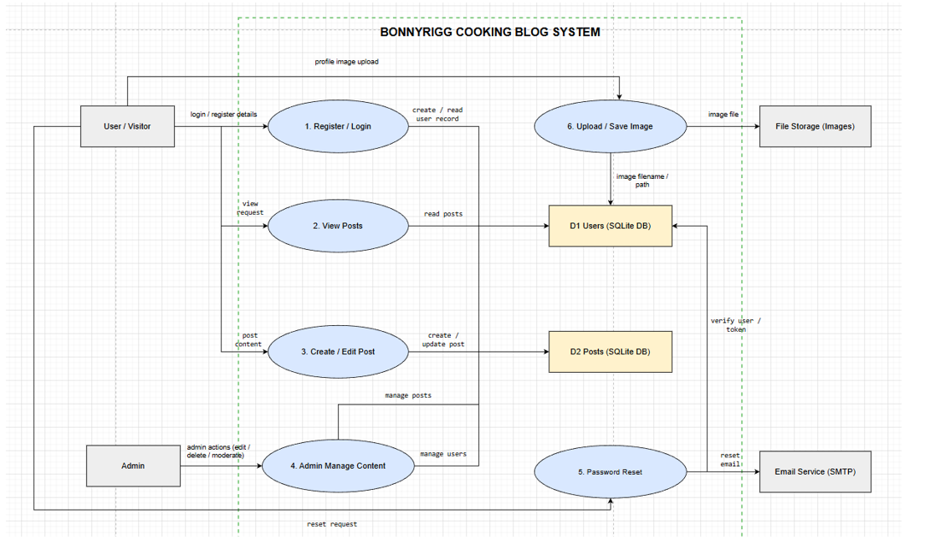

Algorithms (Pseudocode Summary)
Core algorithms include login authentication, 2FA verification, password reset, and recipe filtering. These follow structured logic: input → validation → processing → output.

Class Diagram Explanation
The system consists of three main classes: User, Recipe, and Comment. Relationships include one-to-many (Recipe to Comment). The User class manages authentication and security features.
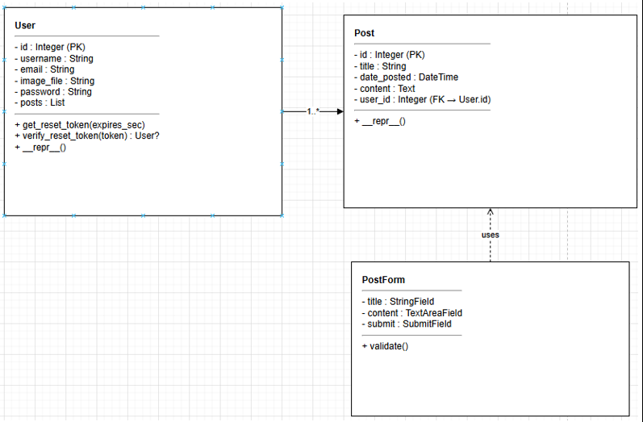

Security Features
The use of SQL Alchemy ORM abstracts direct SQL queries, significantly reducing the risk of SQL injection attacks, while layered authentication mechanisms such as two-factor authentication further strengthen system security beyond standard credential-based access. The system implements password hashing, session management, 2FA (email + authenticator), input validation, file upload protection, and admin access control. ORM prevents SQL injection. These support CIA triad principles.

Advanced Security Considerations
Further improvements include CSRF tokens, rate limiting, HTTPS/SSL deployment, and penetration testing. These are acknowledged and justified as future enhancements.

Development Process
The system demonstrates iterative refinement, transitioning from a basic functional prototype to a secure and user-focused application through the integration of advanced features such as profile management, authentication layers, and administrative control. The system was developed iteratively, evolving from a basic blog into a secure application. Features such as 2FA and profile systems demonstrate progressive enhancement.

Testing and Evaluation
Testing includes functional testing, validation testing, and security testing. Additional testing methods include SAST, penetration testing, and user acceptance testing.

Deployment
Although the system is currently deployed in a local development environment, it is designed to be scalable and compatible with cloud-based deployment platforms, supporting secure HTTPS communication and environment-based configuration. The application runs locally using Flask and can be deployed on Render or PythonAnywhere. Production deployment includes HTTPS, secure environment variables, and scalable infrastructure.

Social Implications
The system promotes safe user interaction and protects user data.

Ethical Implications
Responsible handling of user information and transparency in security practices.

Legal Implications
Aligns with data protection and privacy principles.

Environmental Implications
Lightweight architecture reduces computational resource usage.

Evaluation
The system effectively meets functional and non-functional requirements. Security, usability, and modular design demonstrate high-quality software engineering.

